BONUS
Build Your First GPT in 10 Minutes

You don’t need to be technical. If you can paste text and upload a file, you can build an AI assistant. Here’s the whole process on one page, the same five steps on every platform.
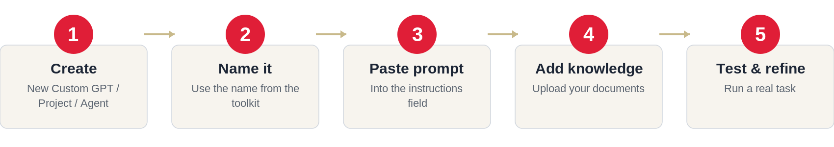
The five steps, explained
1. Create. Open your AI tool and start a new assistant (each platform calls it something different — see below).
2. Name it. Use the name from the toolkit, e.g., “Member Onboarding Journey GPT,” so your team can find it.
3. Paste the starter prompt. Copy the prompt from the guide into the instructions field. Add your association’s name.
4. Add your knowledge. Upload one or two relevant files — your brand voice sheet, a strategic plan, past content. This is the step that makes it sound like you.
5. Test and refine. Run a real task. Where it misses, tighten the instructions and save. Done.

Where each step lives, by platform
Step | ChatGPT (Custom GPT) | Claude (Project) | Microsoft Copilot (Agent)
Create | Sidebar → Explore GPTs → Create | Projects → New project | Copilot app → Agents → New agent
Name it | In the Configure tab | Name the project | Add a name & description
Paste prompt | Into Instructions | Into Project instructions | Into Instructions
Add knowledge | Upload under Knowledge | Upload files to the project | Add files under Knowledge
Use it | Set visibility → Create | Start a chat in the project | Test, then publish/share
Note: saving an assistant for your whole team to reuse generally needs a paid plan (ChatGPT Plus/Team, Claude Pro/Team, or a Microsoft 365 Copilot license). You can paste any starter prompt into a free chat to use it on the spot.
Stuck on your first one? Pick the simplest assistant that solves a real headache, give it one knowledge file, and run three real tasks through it. Momentum beats perfection.

Sherry Budziak, CEO · .orgSource
847.275.1840 | sherry@orgsource.com | www.orgsource.com

Copyright © 2026 .orgSource. All rights reserved. Licensed for the purchaser’s organizational use.

